Lab 10 – Activity Series Results

Use the following pictures to complete the activity series lab.

Solutions and Metals:
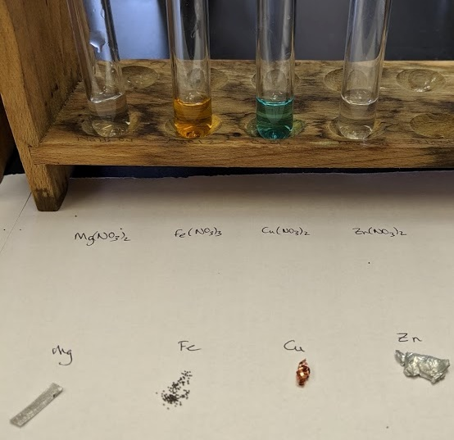

On the following pages are the combinations after the metals have been allowed to react for an extended period of time.
Note that one solution will react with all three metals, one solution will react with two metals, one solution will react with one metal, and one solution will react with no metals and vice versa for the metals.
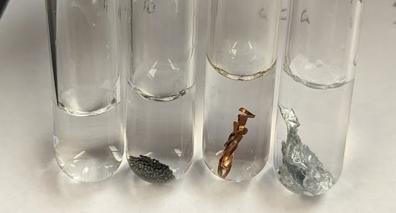
Mg(NO₃)₂ | Mg(NO₃)₂ + Fe | Mg(NO₃)₂ + Cu | Mg(NO₃)₂ + Zn

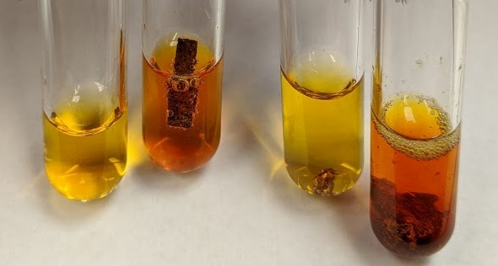
Fe(NO₃)₃ | Fe(NO₃)₃ + Mg | Fe(NO₃)₃ + Cu | Fe(NO₃)₃+ Zn

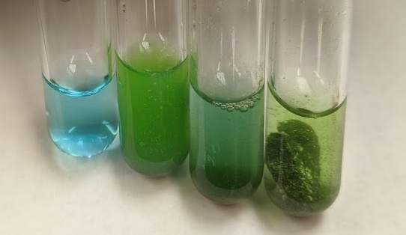
Cu(NO₃)₂ | Cu(NO₃)₂ + Mg | Cu(NO₃)₂ + Fe | Cu(NO₃)₂ + Zn

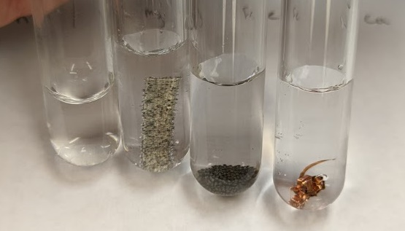
Zn(NO₃)₂ | Zn (NO₃)₂ + Mg | Zn(NO₃)₂ + Fe | Zn(NO₃)₂ + Cu

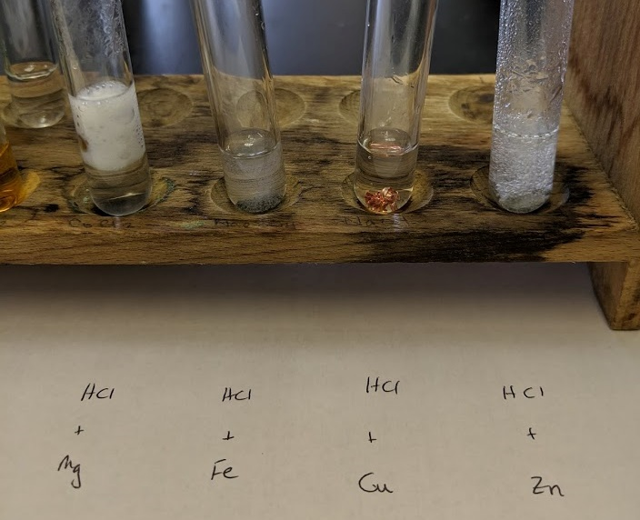
Note, one metal does not react with the HCl.

